|  |  |  |  |  |
| --- | --- | --- | --- | --- |
| Date of creation | 12 March 2022 | | | |
| Document version | 0.2.1 | | | |
| Purpose of the document | This document is intended to present the specification for the system administration module of a medical clinic. | | | |
| Change history | Version | Date | Author | Description |
| 0.0.1.1 | 06.03.2022 | Mateusz Jaruga | Added README.md |
| 0.0.1.2 | 06.03.2022 | Mateusz Jaruga | Generate default project file ASP.NET (.NET Framework) |
| 0.0.2 | 08.03.2022 | Mateusz Jaruga | Updating the workspace |
| 0.0.2.1 | 09.03.2022 | Mateusz Jaruga | Updated once more files hi, started login module. |
| 0.0.2.2 | 09.03.2022 | Mateusz Jaruga | Created new class with some information about user |
| 0.0.3 | 09.03.2022 | Mateusz Jaruga | Working login system with login and password |
| 0.0.3.1 | 09.03.2022 | Mateusz Jaruga | Full login system |
|  | 0.0.3.2 | 09.03.2022 | Mateusz Jaruga | Updated login system |
| 0.0.4 | 09.03.2022 | Mateusz Jaruga | Logout of the system |
| 0.0.4.1 | 09.03.2022 | Mateusz Jaruga | Updated LoginToSystem |
| 0.0.4.2 | 09.03.2022 | Mateusz Jaruga | Added cancel button that clears the textbox |
| 0.0.4.3 | 09.03.2022 | Mateusz Jaruga | Now user can’t enter to the About.aspx page without logging in |
| 0.0.4.3.1 | 10.03.2022 | Mateusz Jaruga | Added comments |
| 0.0.4.3.2 | 10.03.2022 | Mateusz Jaruga | Updating the comments |
| 0.0.4.4 | 10.03.2022 | Mateusz Jaruga | Added label with warning about login attempts |
| 0.0.4.4.1 | 10.03.2022 | Artur Górecki | Updating the comments |
| 0.0.4.5 | 12.03.2022 | Mateusz Jaruga | Update of the warning label |
| 0.0.4.6 | 12.03.2022 | Mateusz Jaruga | Updating the IF conditional in warning label |
| 0.0.5 | 12.03.2022 | Mateusz Jaruga | Updated Administrators’ page and Employees’ page |
| 0.0.5.1 | 12.03.2022 | Hubert Nowicz | Adding the css style and changing the appearance of the login page |
| 0.0.6 | 12.03.2022 | Artur Górecki | Created a new folder to store the documents |
| 0.0.6.1 | 12.03.2022 | Artur Górecki | Added the “Functional Tests – System administration module.xlsx” file |
| 0.0.6.2 | 12.03.2022 | Artur Górecki | Deleted a temp file that was needed to create a new folder |
| 0.0.6.3 | 12.03.2022 | Hubert Nowicz | Branch merging |
| 0.0.6.4 | 12.03.2022 | Hubert Nowicz | Adding the css style and changing the appearance of the login page |
| 0.0.6.5 | 12.03.2022 | Mateusz Jaruga | Scaling branches |
| 0.0.6.6 | 12.03.2022 | Mateusz Jaruga | Reverted changes |
| 0.0.6.7 | 12.03.2022 | Mateusz Jaruga | Reverted changes |
| 0.0.6.8 | 12.03.2022 | Mateusz Jaruga | Scaling branches |
| 0.0.6.9 | 12.03.2022 | Artur Górecki | Added System Documentation.docx to /Documents |
| 0.0.7 | 13.03.2022 | Mateusz Jaruga | Added password hashing |
| 0.0.7.1 | 13.03.2022 | Mateusz Jaruga | Created new page with form to get link for resetting password |
|  | 0.0.7.2 | 17.03.2022 | Mateusz Jaruga | Security updated – prevented SQL injections |
|  | 0.0.7.3 | 17.03.2022 | Artur Górecki | Updated the documents |
|  | 0.0.7.3.1 | 17.03.2022 | Mateusz Jaruga | Branch scaling |
|  | 0.0.7.4 | 17.03.2022 | Mateusz Jaruga | Security update |
|  | 0.0.7.4.1 | 18.03.2022 | Mateusz Jaruga | Merging secondary branch, ‘MedicalWithHashing’, with the main one |
|  | 0.0.8 | 19.03.2022 | Mateusz Jaruga | Added user session system |
|  | 0.0.9 | 22.03.2022 | Mateusz Jaruga | Created the basis for a system to send emails with a link to change the password |
|  | 0.0.9.1 | 22.03.2022 | Mateusz Jaruga | Merging project with a new module: Business Administration |
|  | 0.0.9.2 | 22.03.2022 | Mateusz Jaruga | Changed the file hierarchy, to prevent mixing documents from different modules |
|  | 0.0.10 | 23.03.2022 | Mateusz Jaruga | Added timer and input blocking |
|  | 0.0.10.1 | 23.03.2022 | Mateusz Jaruga | Corrected names of class namespaces |
|  | 0.0.10.2 | 23.03.2022 | Artur Górecki | Changed the message about the remaining locktime and locked input fields |
|  | 0.0.10.3 | 23.03.2022 | Mateusz Jaruga | Branch merging |
|  | 0.0. |  |  |  |
|  |  |  |  |  |

1. System administration module
   1. Login/logout

Functionalities of login into the system and logout from the system is part of the administration module but is actually used for getting access to each of the modules.

All users use this part of the system to log in/log out.

After correct login, the system automatically opens the appropriate module based on logged user’s rights.

**Epic: Login**

**User stories:**

* + 1. Logging into the system

|  |  |
| --- | --- |
| Name | Login into the system |
| ID | LOG_01 |
| The aim | Login the user into the system |
| Description | Non-logged user has the possibility to login into the system. For the login user has to put two kinds of information:   * Login name * Password   After the correct login process, the system launches the proper module, based on the user’s rights |
| Author | Jarosław Zając |
| Actor | Non-logged user |
| Start conditions | N/A |
| Finish conditions | User logged-in  Appropriate module launched |
| Input data | Login name  Password |
| Output data | N/A |
| Scenarios | Main:   1. User launches system 2. System opens login window 3. User puts input data 4. System checks that data is correct 5. System launches appropriate module, based on user rights   Alternative:  Incorrect input data –not more then two times in a row   1. System checks that input data is incorrect 2. System views message with error details   3rd incorrect data input in a row   1. System checks that input data is incorrect 2. System lock possibility of login data input (login name and password fields are unavailable) 3. System starts to show time to remain to unlock the system |
| Notices |  |

* + 1. Resigning of logging in

|  |  |
| --- | --- |
| Name | Resigning of logging in |
| ID | LOG_02 |
| The aim | Cancel logging in process |
| Description | Non-logged user has the possibility to cancels the login process before confirming the login details.   * Once the "Cancel" button is pressed the login form is closed |
| Author | Mikołaj Uznański |
| Actor | Non-logged user |
| Start conditions | N/A |
| Finish conditions | User is not logged-in  Empty login form is closed. |
| Input data | N/A |
| Output data | N/A |
| Scenarios | Main:   1. User launches system 2. System opens login window 3. User can enter his login data or leave the fields empty. 4. User presses the Cancel button. 5. The user is taken to an empty login form. |
| Notices |  |

* + 1. Incorrect login

|  |  |
| --- | --- |
| Name | Incorrect login |
| ID | LOG_05 |
| The aim | System checks correction of input login data |
| Description | System checking if user login data is correct which enables safes access to the system for proper users only.  Acceptance criteria:   * Once input data is incorrect, the system generates and views a message with information about incorrect input data |
| Author | Mikołaj Uznański |
| Actor | Non-logged user |
| Start conditions | The non-logged user is trying to get access to system. |
| Finish conditions | The system presents a message indicating that the user is entering incorrect data. |
| Input data | Login name  password |
| Output data | N/A |
| Scenarios | Main:   1. User launches system 2. System opens login window 3. User trying to login with incorrect login data. 4. System verifies the entered data. 5. The system generates and views a message with information about incorrect input data. |
| Notices |  |

* + 1. System blocking

|  |  |
| --- | --- |
| Name | System blocking |
| ID | LOG_06 |
| The aim | System blocking the possibility of logging again for entering incorrect data for the third time in a row. |
| Description | The system is blocking the possibility of logging again for chosen time (parameter) X when user trying to entering incorrect input data three times in a row, which provides the security of the system will by higher.  Acceptance criteria   * The third incorrect login data entering causes blocking of the possibility of using next attempt of login (entering input data) * The system starts showing the time remaining to unlock the possibility of entering input data |
| Author | Mikołaj Uznański |
| Actor | non-logged user |
| Start conditions | The non-logged user uses incorrect login data three times |
| Finish conditions | System blocking for the user the possibility of logging again for X (parameter) minutes |
| Input data | N/A |
| Output data | N/A |
| Scenarios | Main:   1. User launches system. 2. System opens login window. 3. User uses incorrect login data. 4. System verifies the entered data. 5. After third unsuccessful attempt the system blocks input data fields and the login button and the system informs the user about the remaining time during which they cannot log in. |
| Notices |  |

* + 1. Input data unlock

|  |  |
| --- | --- |
| Name | Input data unlock |
| ID | LOG_07 |
| The aim | System automatically unlocks the possibility of entering input data |
| Description | The system is automatically unlocks the possibility to enter login in data for non-logged user. When locking time is over, user get access to try to login again.  Acceptance criteria   * If the time of system locking is complete, input data fields are available again and information about time to unlock disappears |
| Author | Mikołaj Uznański |
| Actor | non-logged user |
| Start conditions | The system is blocked for X (parameter) minutes |
| Finish conditions | System automatically unlocks the possibility of entering input data. |
| Input data | N/A |
| Output data | N/A |
| Scenarios | Main:   1. System starts counting lockout time and shows the time remaining to unlock the possibility of entering input data. 2. The time for blocking access has ended. 3. User get access to input data login once again. |
| Notices |  |

**Epic: Password changing**

**User stories**

WORK IN PROGRESS  


**Epic: Logout**

* + 1. Logging out from the system

|  |  |
| --- | --- |
| Name | Logging out from the system |
| ID | LOG_03 |
| The aim | Logged-in user have possibility to log out from the system |
| Description | The user has the possibility to ends his work with the system safely and correctly by logging out of it. After that user sees system login form with empty fields. |
| Author | Mikołaj Uznański |
| Actor | Logged-in user |
| Start conditions | The user is logged-in |
| Finish conditions | User has been logged out of the system.  User is not logged-in, system presents login form with empty fields |
| Input data | N/A |
| Output data | N/A |
| Scenarios | Main:   1. User is logged in to the system. 2. The user presses the Logout button. 3. The system displays a logout attempt message. 4. The user presses the OK button. 5. User is logged out from the system   Alternative:  User decided to   1. The users presses the cancel button. 2. Message window is closed |
| Notices |  |

* 1. System user management – clinic staff

To be done

* 1. System parameters and dictionaries management

To be done

1. Diagrams
   1. Login/logout

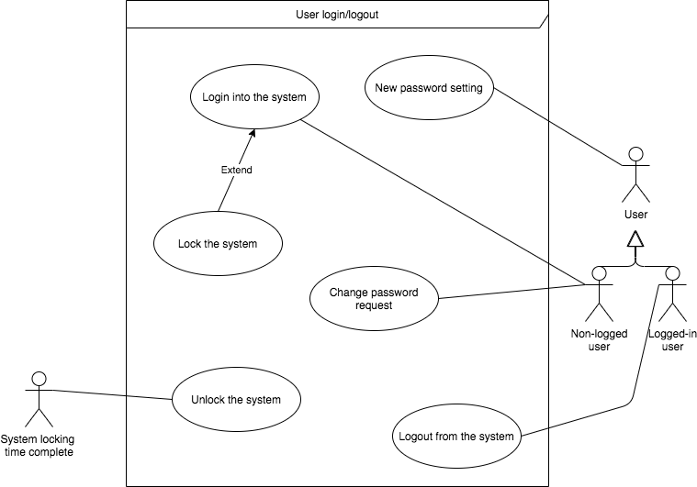

* 1. System user management – clinic staff

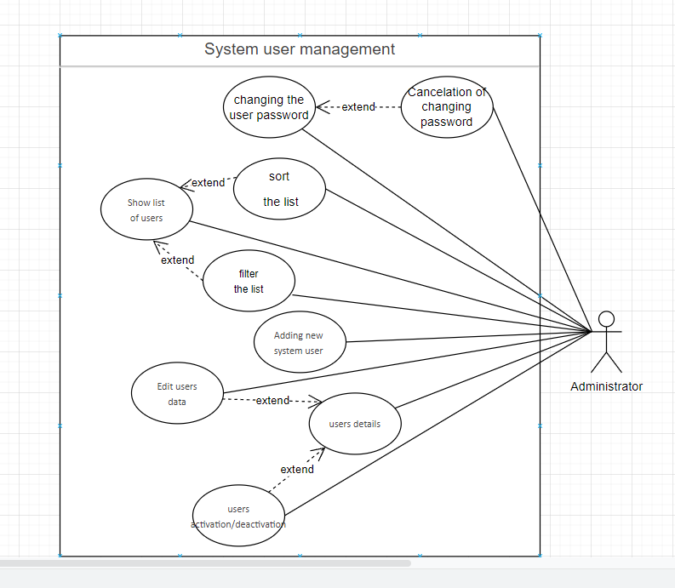

* 1. System parameters and dictionaries management

